# Architecture of GIT:

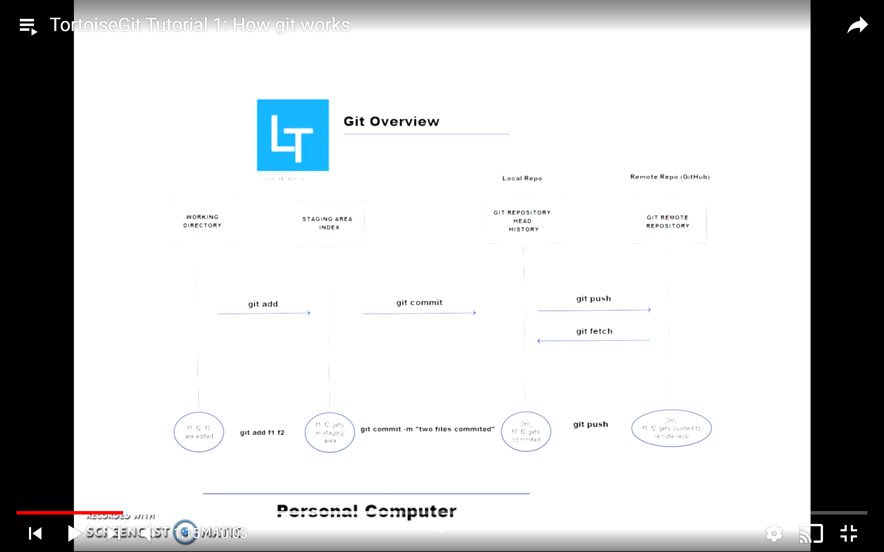

Step wise Tutorial:

**Login to GitHub.com and create an account:**

1. Create a repository in you profile
2. Copy the URL of repository for cloning : similar to this <https://github.com/himanshuporwal3/GitLearnTG.git>

On your PC:

1. Create an empty folder with a name:
2. **Right Click the folder and Select GIT Clone :**

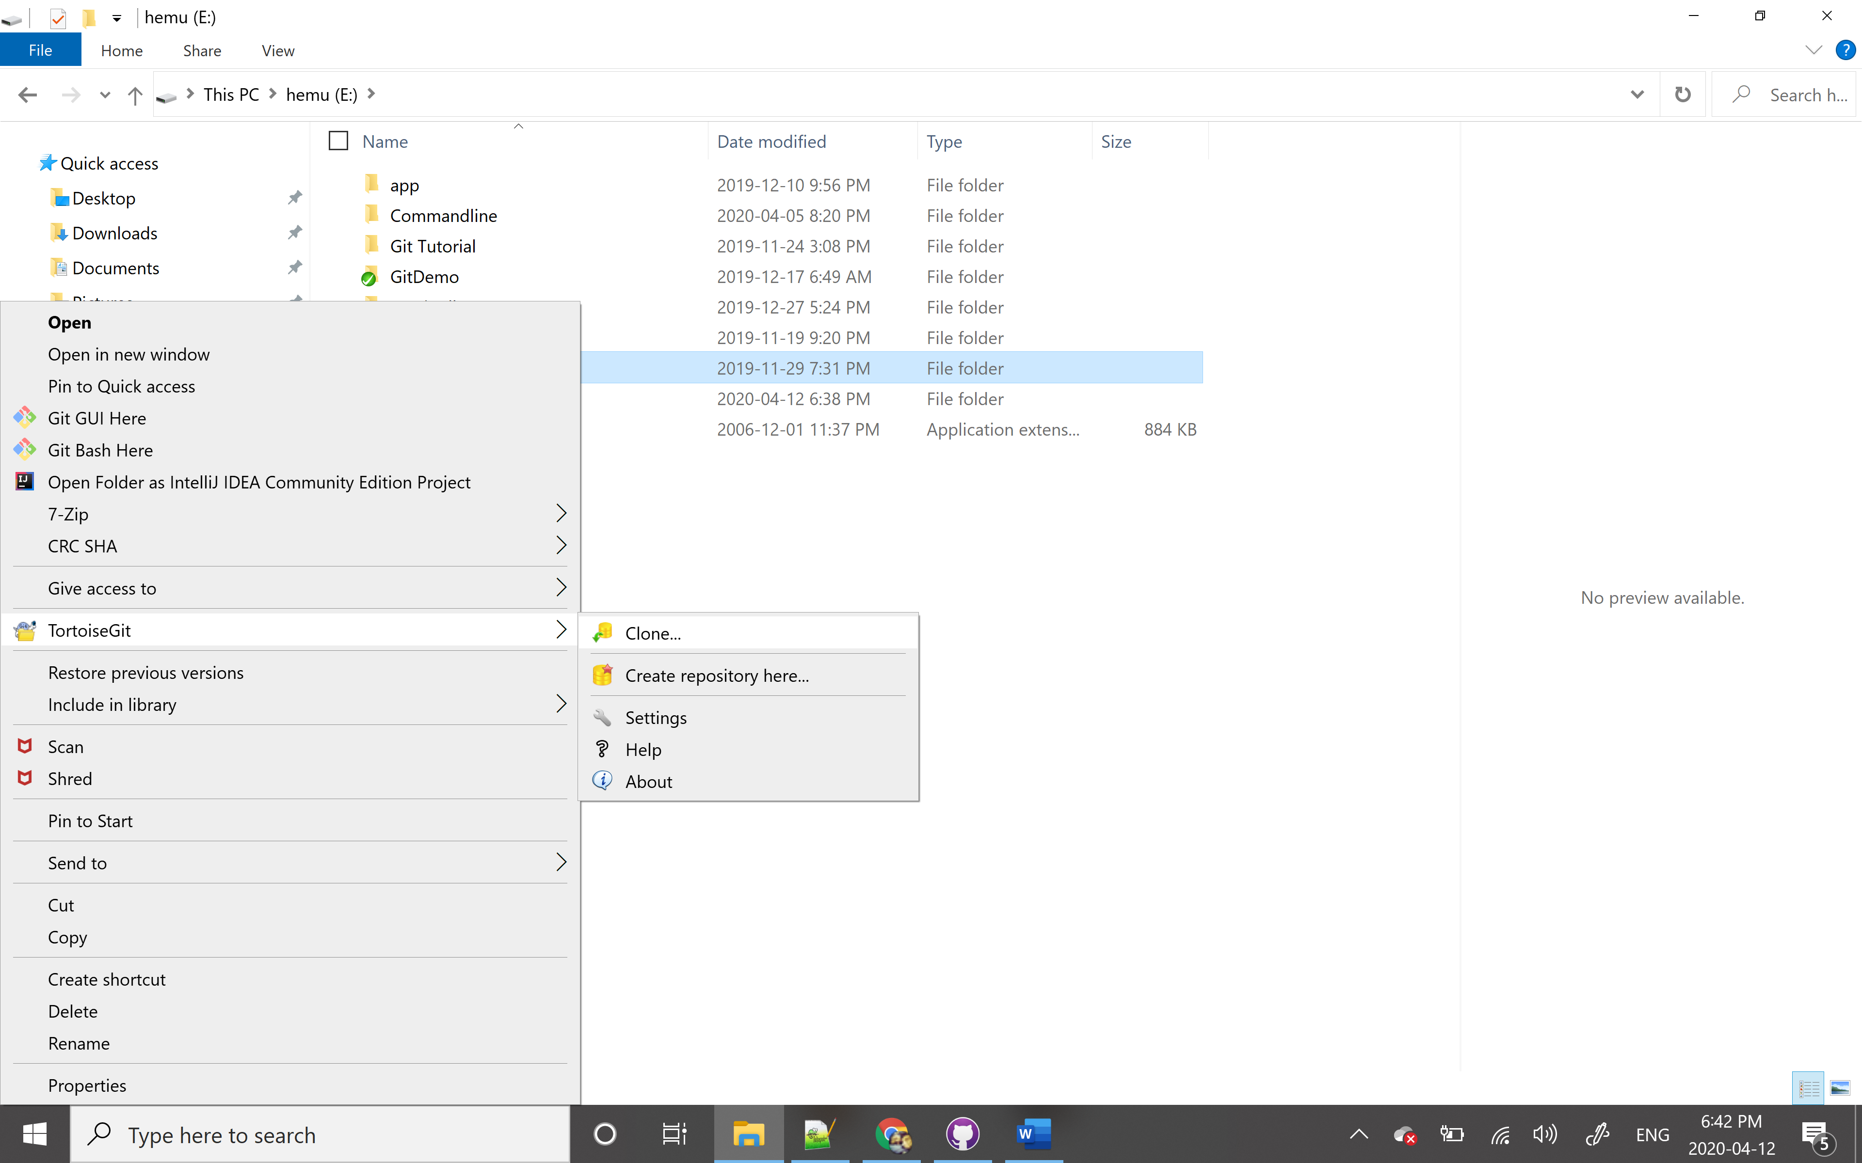

1. Paste the URL as shown in below screen, click OK.

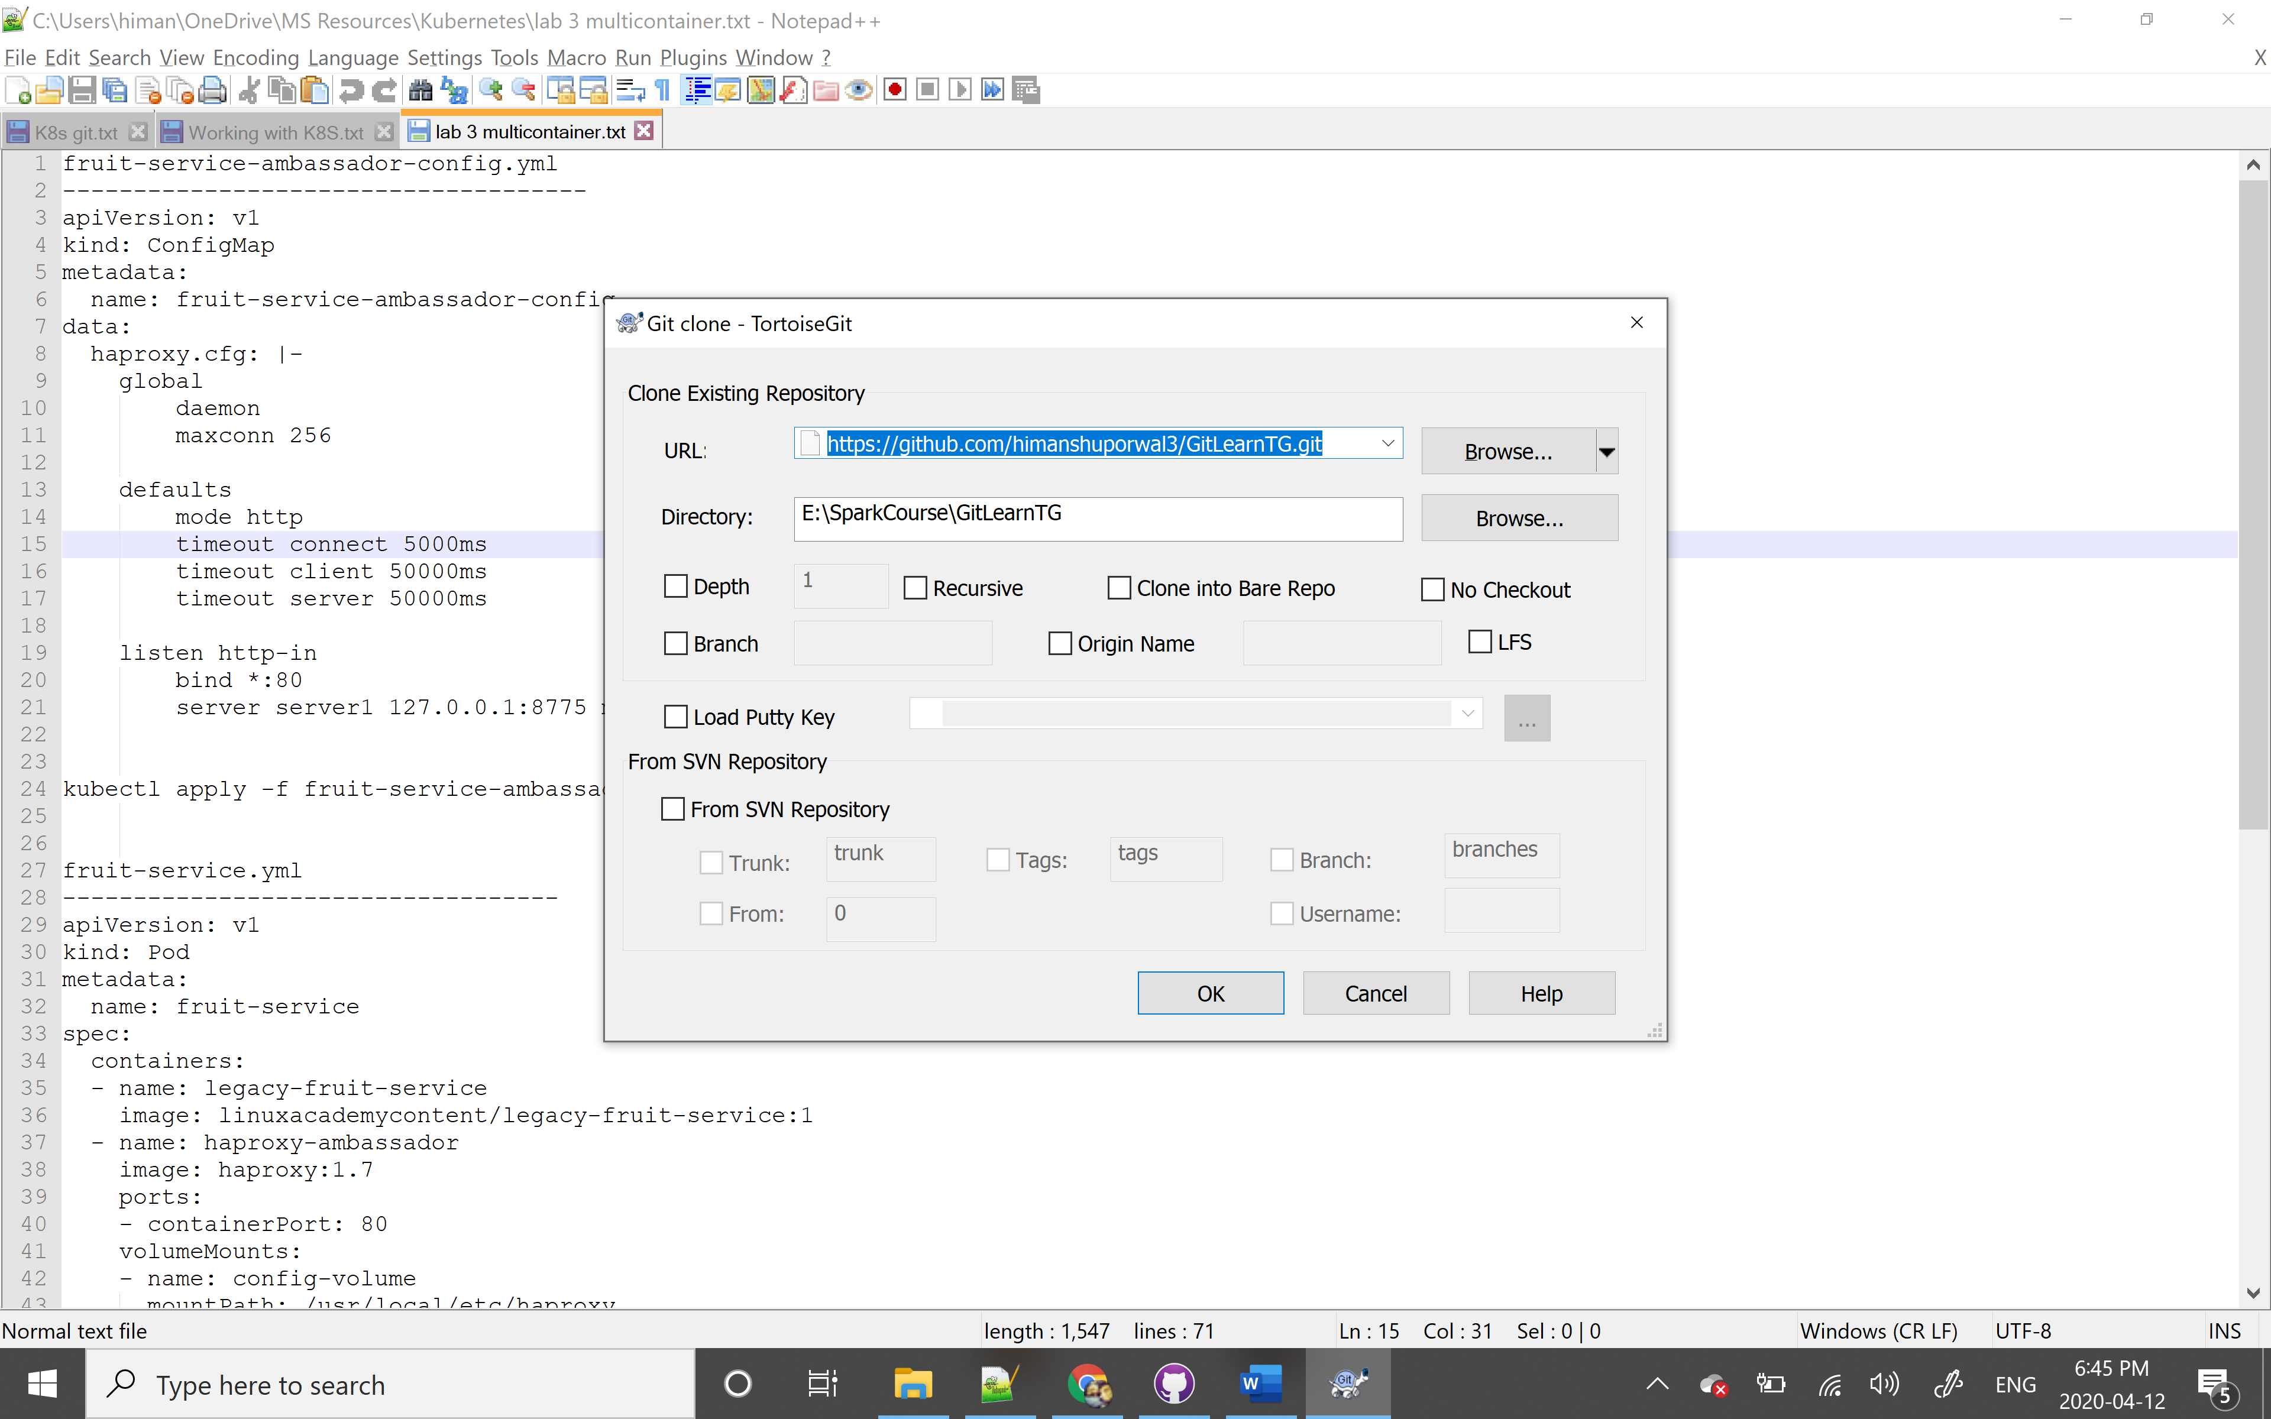

1. Create and modify a file.
2. Check for modification – will show all the changed files.

